LTI Interview question:
Col A Col B
A 1
B 2
C 3
D 4
Output format is like :
ColA ColB
ABCD 1
ABCD 22
ABCD 333
ABCD 4444

Python code:
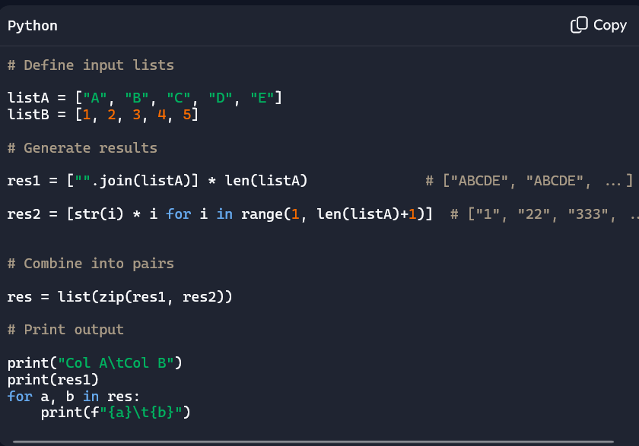

PySpark Code:
from pyspark.sql import SparkSession
from pyspark.sql.functions import lit, col, expr
# Initialize Spark
spark = SparkSession.builder.appName("ProjectsExample").getOrCreate()

# Input data (listA and listB as Spark DataFrame)
listA = ["A","B","C","D","E"]
listB = [1,2,3,4,5]
# Create DataFrame from zipped lists
df = spark.createDataFrame(zip(listA, listB), ["listA", "listB"])
# Create Col A: join of listA repeated for each row
joined_str = "".join(listA) # "ABCDE"
df = df.withColumn("Col A", lit(joined_str))
# Create Col B: string of listB repeated 'listB' times
# Equivalent to [str(i)*i for i in range(1,len(listA)+1)]
df = df.withColumn("Col B", expr("repeat(string(listB), listB)"))
# Select only required columns
result_df = df.select("Col A", "Col B")
# Show results
result_df.show(truncate=False)

Useful Python Functions:

join() in Python
- Purpose: Concatenates elements of a list (or iterable) into a single string, using a specified separator.
- Syntax:
- "separator".join(list)
- Example:
- "".join(["A","B","C","D"]) # "ABCD"
- "-".join(["A","B","C"]) # "A-B-C"
- Key Point: The separator string goes before .join(), not after.

zip() in Python
- Purpose: Combines multiple iterables element-wise into tuples.
- Syntax:
- zip(iterable1, iterable2, ...)
- Example:
- listA = ["A","B","C"]
- listB = [1,2,3]
- list(zip(listA, listB)) # [("A",1), ("B",2), ("C",3)]
- Key Point: Stops at the shortest iterable length. Useful for pairing values.

Useful Pyspark functions

repeat() in PySpark
- Purpose: Repeats a string value a specified number of times.
- Function: repeat(str, n)
- Usage: Available in SQL expressions or via expr() in PySpark.
- Example:
- from pyspark.sql.functions import expr

- df = spark.createDataFrame([(1,), (2,), (3,)], ["num"])
- df = df.withColumn("repeated", expr("repeat(string(num), num)"))
- df.show()
- Output:
- +---+--------+
- |num|repeated|
- +---+--------+
- | 1|1 |
- | 2|22 |
- | 3|333 |
- +---+--------+
- Key Point: Converts the column to string first, then repeats it n times.

